Protekt® Deluxe Nebulizer
w/Disposable and Reusable Kit
MODEL NO: PMNEBRDK
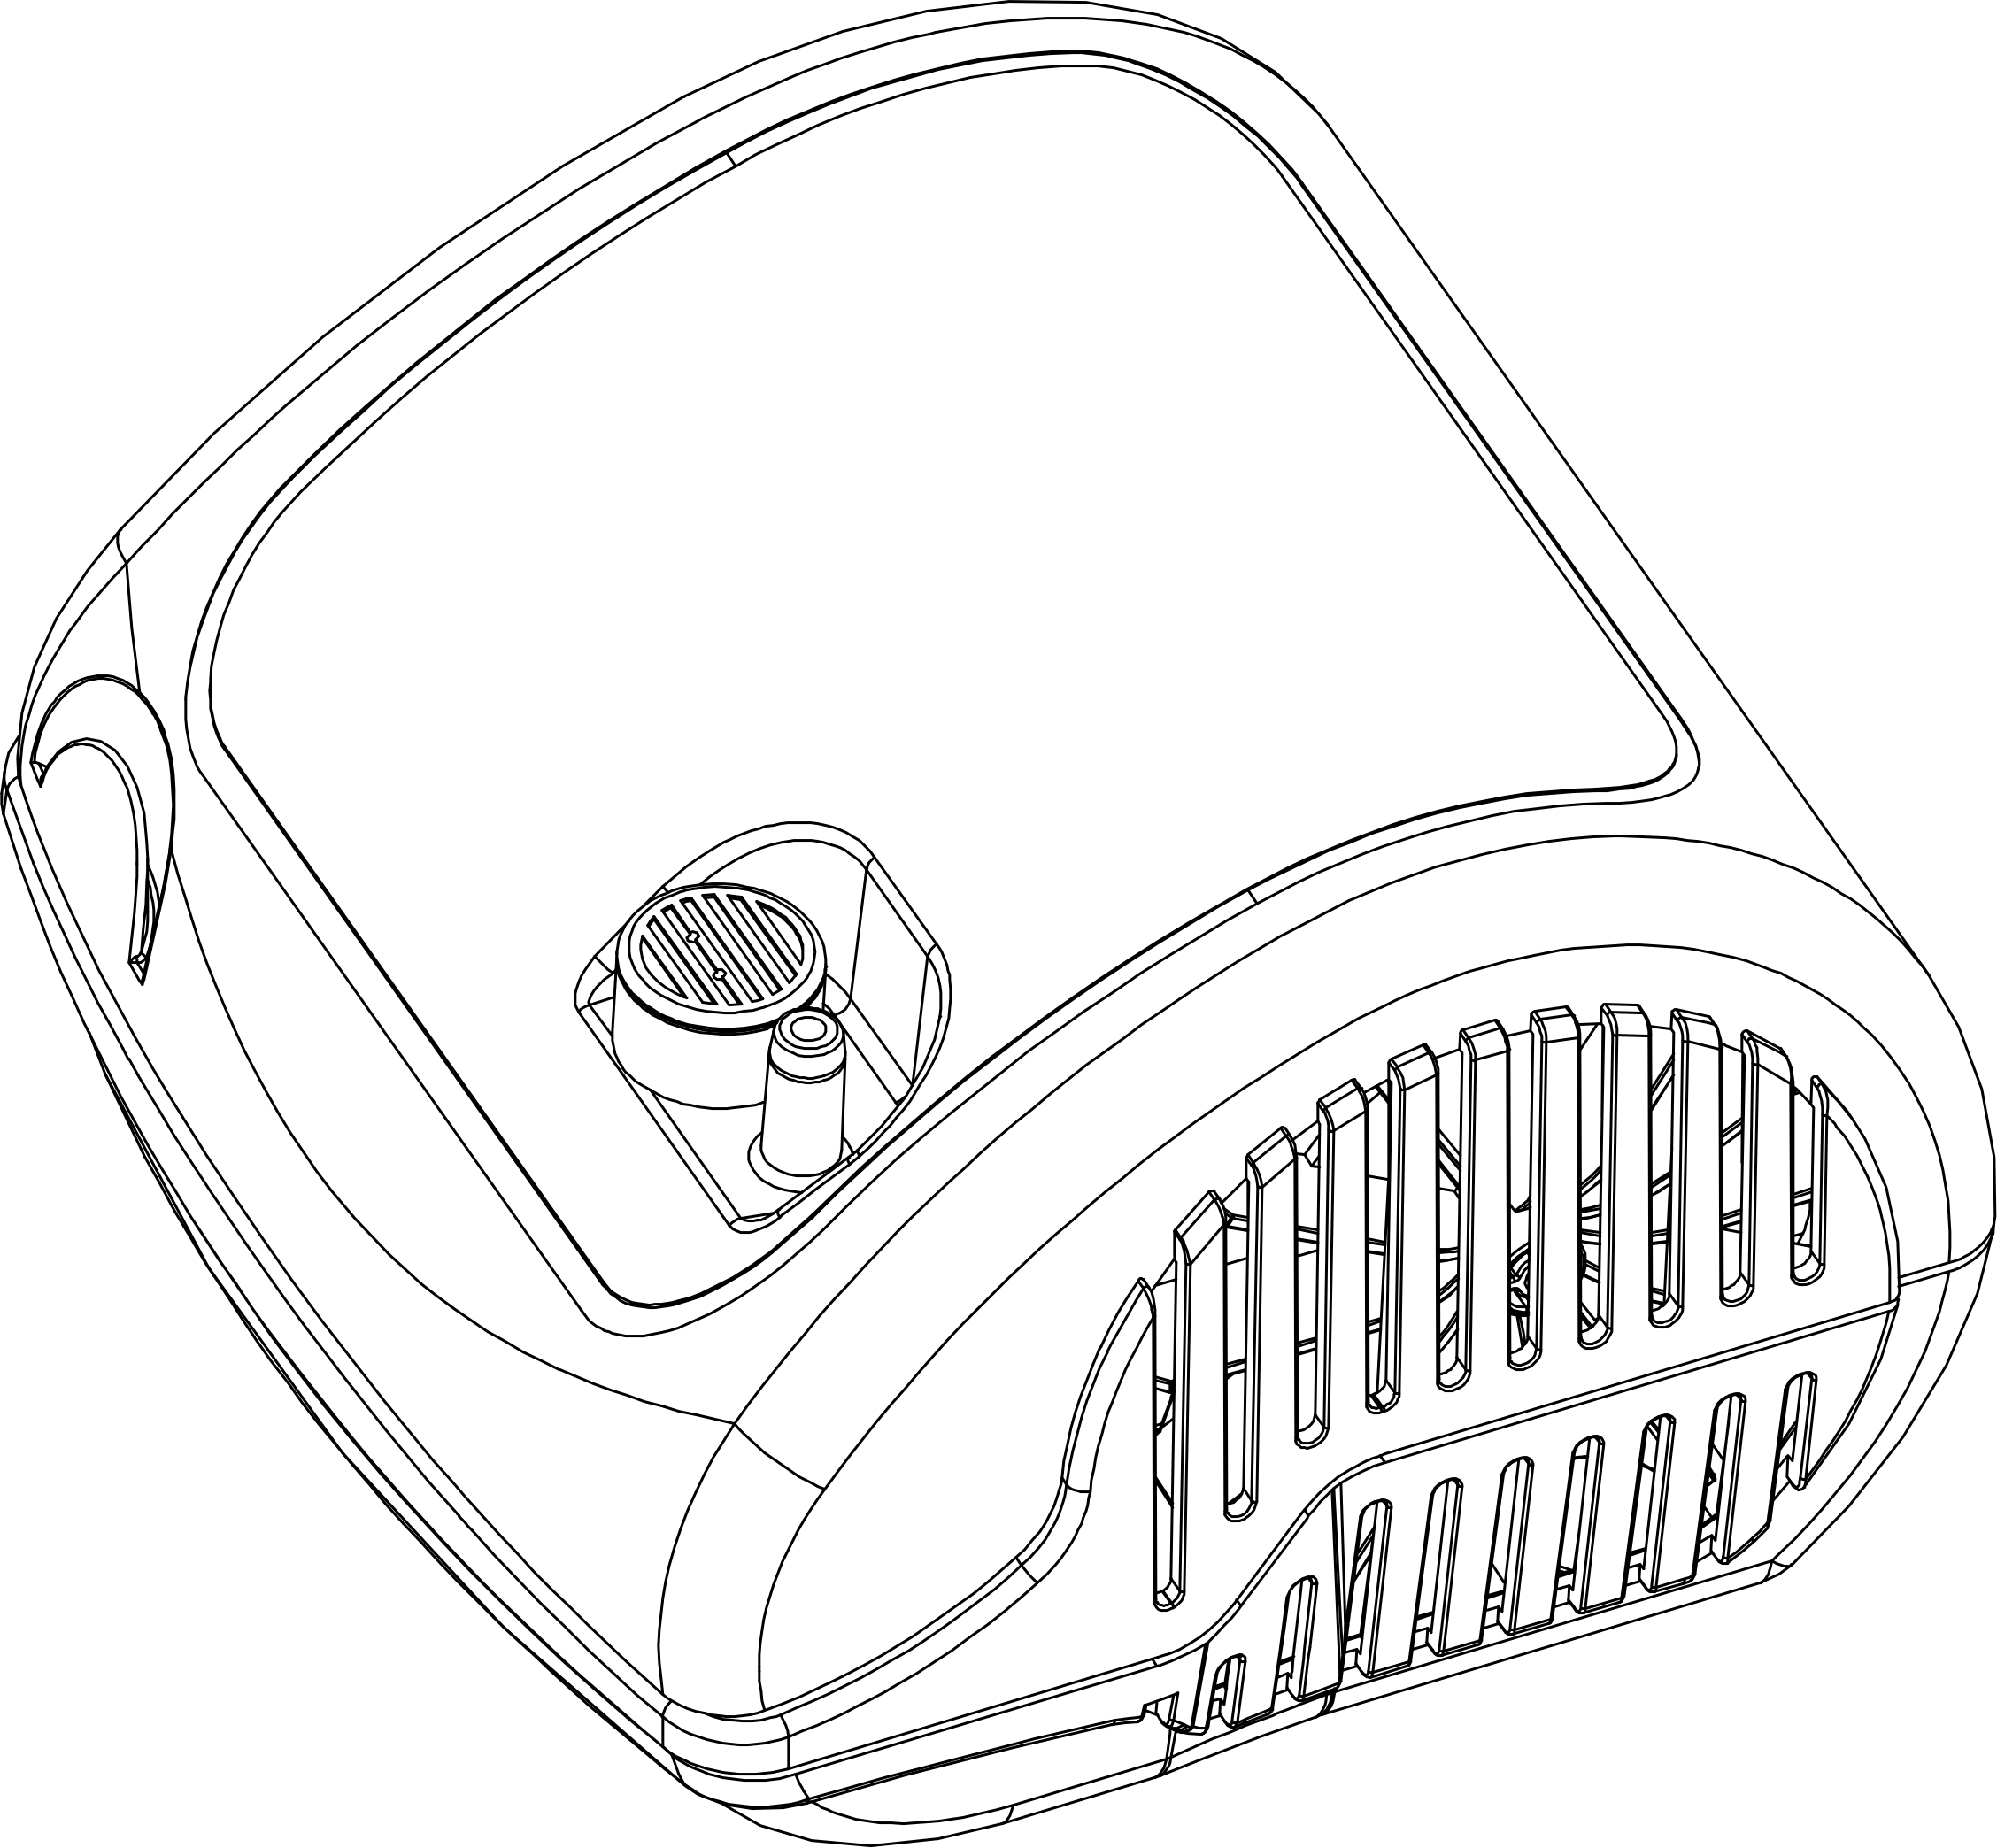

Instruction Manual

Instructions for Use
The Proactive Compressor Nebulizer is an AC-powered air nebulizer compressor system intended to provide a source of compressed air for medical purposes for use in home healthcare. It is to be used with a nebulizer kit to produce medicated aerosol particles for respiratory therapy for both children and adults.
Important: Read these instructions carefully before using this device.
Caution
Caution: Federal law restricts this device to sale by or on the order of a physician
Use the device only for its intended purpose as described in these instructions for use as a compressor nebulizer system for aerosol therapy. Follow the instructions of your doctor. Any other form of use constitutes improper use and may be dangerous. The manufacturer cannot be held liable for any damage caused by improper, incorrect, or unreasonable use, or if the unit is connected to electrical installations not complying with safe regulations.
Keep this manual for future reference.
Do not operate the unit in the presence of any anesthetic, flammable mixtures, or oxygen.
Correct device operation can be affected by electromagnetic interference. If this device interferes with another electrical apparatus, remove it and plug it into a different electrical outlet.
In case of failure and/or malfunction, do not open the compressor housing, as this is not a serviceable product.
The proper function of the device can be compromised if original
replacement parts (e.g., filter) are not used.
When using any electrical appliance, certain important safety measures must always be observed, including the following:
• Never submerge the unit in water, as the device is not protected against water penetration
• Never touch the unit if hands are wet or moist
• Do not leave the unit outdoors
• Place on stable and horizontal surface when operating
• Make sure the air vent openings area unobstructed
• Do not allow unsupervised children or physically challenged individuals to use the unit
• Turn the unit off with the power switch. Do not pull plug out from electrical outlet while the power is on.
Make sure that the electrical rating shown on the rating plate on the bottom of the unit corresponds to your main voltage and frequency before plugging in the device.
Do not use electrical adapters including extension cords.

Do not leave the unit plugged in when not in use. Unplug the device from the electrical outlet when not in operation.
Follow the manufacturer’s instructions for installing the device. The manufacturer cannot be held responsible for any damage caused by incorrect installation.
The power supply cord cannot be replaced by the user.
The power supply cord should always be fully unwound in order to prevent dangerous overheating.
Before performing any cleaning operation or filter replacement, disconnect the device from the main supply by unplugging it or by turning the main supply switch OFF.
Some parts of the unit are small enough to be swallowed by children. Do not let unattended children have access to the unit.
If you decide not to use the device, it is recommended to dispose of it according to local regulations.
Remember to:
• Use this device only with medications prescribed by your doctor
• Use the accessories recommended by your doctor for therapy
Verify that the medications prescribed by your doctor can be used with common compressor nebulizer systems for aerosol therapy.

Warranty
Proactive Medical offers a limited 5-year warranty on the compressor unit to be free from defects in material and workmanship under normal use and operation for a period of 5 years from date of original retail purchase. This warranty does not extend to failures resulting from accidental damage, misuse, negligence, abuse, alteration, or improper operation. This warranty does not extend to non-durable components which are subject to normal wear and need periodic replacement. All items returned must be properly packaged and shipped in a manner to avoid shipping damage.

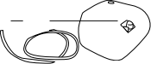
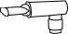
Nozzle

Instructions for Use with T-Piece Kit

Examine the unit before the first use in order to check
for possible shipping damage. When taking a treatment sit
upright and relaxed.
1. After unpacking the device, check the compressor and accessories for visible damage or defects such as cracks in the plastic housing, which could expose electrical components. Contact your retailer to report any damaged product.
2. Before using the device, follow the cleaning instructions as detailed in this user manual.
3. Attach the supply tube to the compressor and to the bottom of the nebulizer cup.
4. Open the nebulizer cup by pushing down on the cap and twisting counter-clockwise.
5. Add prescribed medication into nebulizer cup then turn top on until secure.
6. Attach mouthpiece to the nebulizer bottle.
7. Connect the tube to the nebulizer bottle and the nebulizer machine.
8. Ensure connections are secure before turning on the nebulizer machine.
9. Plug the compressor into the electrical outlet, making sure the electrical rating shown on the rating plate on the bottom of the unit corresponds to your main voltage.
10. To start treatment, switch the compressor on by pressing the ON/OFF switch onto the “I” position.
ATTENTION: This device rated for intermittent use
30 minutes ON / 30 minutes OFF.
11. When mist is visible, begin inhaling with the mouthpiece.
12. When the treatment has been completed, switch the unit OFF by setting the switch position to “O” and disconnect the plug from the electrical outlet.
13. Wash the nebulizer and accessories as described in the cleaning section.

Troubleshooting
If the device does not turn on:
1. Make sure the plug is firmly inserted into the electrical outlet.
2. Make sure the device has been operating within the limits indicated in this instructional manual (30 minutes ON/30 minutes OFF).
If the device does not nebulize, or the nebulization is weak:
1. Make sure the ends of the air tube are fitted tightly onto the main unit and onto the nebulizer (see connected kit and unit diagram below)
2. Check whether the nebulizer mask or mouthpiece kit cup chamber is empty or overfilled with medication.
3. Check whether the nebulizer nozzle is obstructed (see medicine cup diagram below)
4. Check whether the baffle is inserted properly. The baffle fits over the medicine cup’s interior cone (see medicine cup diagram below).

Connected kit and unit

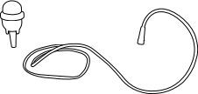
Fit tube ends
tightly

Medicine cup
Exploded view
Closed view

Baffle

Cleaning
Cleaning of the compressor
Use a clean dry cloth and mild detergents to clean the outside of
the unit.
ATTENTION: During cleaning, make sure the internal parts of the unit
are not in contact with liquids and the power cord is disconnected.
Cleaning and disinfection of the accessories
After each use, disassemble the kit into 3 sections. Wash in warm
soapy water and rinse well. Wipe with a paper towel and allow to air dry.
Do not boil or autoclave angled mouthpieces, air tubes, or masks.
It is important that the cleaning instructions are carefully
followed to ensure optimal operation.

Replacement of Nebulizer Kit

Disposable Nebulizer Kit with Green Nozzle
The disposable nebulizer kit should be replaced after a long
period of inactivity, or if it is obstructed by dry medication, dust, etc.
With normal use, the disposable nebulizer kit should last 1 month.

Reusable Nebulizer Kit with Beige Nozzle
The reusable nebulizer kit should be replaced after a long period
of inactivity, or if it is obstructed by dry medication, dust, etc. With
normal use, the reusable nebulizer kit should last 6 months.
Replacement of the filter

The filter is to be replaced after approximately 30 hours of use, or when it appears dirty. Open the filter holder to replace the filter with a new one.

Do not use the device without the filter.

Maintenance and Repair
Never open the device. There are no serviceable parts within the unit.
The compressor does not require lubrication or maintenance.

Proactive Medical Products
270 Washington Street
Mount Vernon, NY 10553
Tel: 855-237-7622 / Fax: 845-205-6005
www.proactivemedical.com

